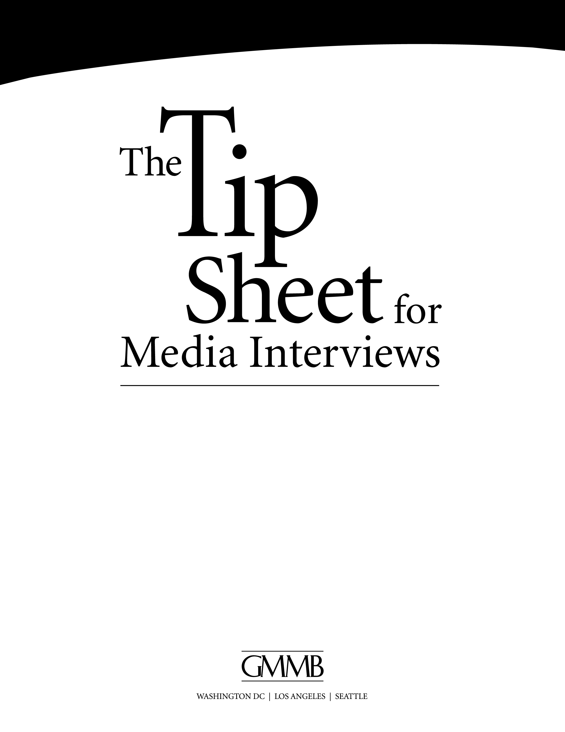

The Role of a Spokesperson 3
The Use of the Media 3
Truths About Media 3
Before the Interview 3
During the Interview 4
After the Interview 6
Special Tips: Television Interviews 6
Special Tips: Satellite TV Interviews 8
Special Tips: Conference Phone Interviews 8
Special Tips: Radio Interviews 9
Special Tips: Print Interviews 9
Sample Bridging Phrases 9

The Role of a Spokesperson

Serves as a reputable, reliable source of information

Sets the tone for the campaign

Delivers the campaign’s message

Looks for new opportunities to inform

Speaks at a variety of venues

Is comfortable with being a public figure

The Use of the Media

Tells your story

Amplifies your message and allows you to communicate with thousands of individuals at a time

Lends credibility to your message: “I read it in the paper”

Truths About Media

It can be hard to control the story

The cameras are always on

Before the Interview
- Know your message
What do you want your audience to take away? Continue to emphasize and repeat this main idea throughout the interview.
- Develop three to five messages or “talking points”
These are the main ideas you want to emphasize and repeat during your interview. Weave these points into all of your answers. Anticipate what questions may be asked and be prepared with answers. If you are successful at “staying on message,” you can help shape the news story.
- Learn more about the reporter and outlet
Visit their outlet’s Web site to read/watch their previous stories and find out more about their typical audience. The type of outlet will have an impact on the sort of talking points that you prepare. This will help you understand what their range of knowledge is on a topic, what their perspective or reporting style might be, and what they might ask you in your interview. You can also find out more about many reporters by visiting MediaBios at www.tjfr.com.
- Chat with the interviewer
Before the interview begins, chat with the reporter to make sure you both have an understanding of the topics that will be discussed. This is especially important for broadcast interviews, so you do not get caught off-guard on camera.
- Learn more about the story
Find out the goal of the story and try to get a sense of the types of questions that you may be asked.
- Rehearse anticipated questions
After you have an idea of what the reporter might ask, practice your answers to these questions a few times. Even better, do it in front of a mirror, a friend or a video camera.
- Understand the reporter’s timeline
Find out when the reporter must complete the story and plan your interview accordingly. You should plan to accommodate the reporter’s deadline, so they won’t feel rushed and your interview will go more smoothly.
- Relax and focus
Get to your location early (10-15 minutes), and spend time practicing your core message points. Some people find breathing exercises help them relax and calm jittery vocal cords.

During the Interview
- Make your first words the most memorable
Interest levels diminish quickly, so make the first words out of your mouth the most memorable. If the interview is taped, take your time before speaking to clarify your thoughts. The producer will edit the pauses.
- Keep your audience in mind
The reporter you are speaking with is not your target audience. You are speaking to people as they watch the TV news in their living rooms, listen to the radio in their cars, or read newspapers on the subway. Communicate in a way that engages them. Speak “real American”—don’t use arcane jargon—and always try to translate your “news” to their lives in a way that is relevant and compelling.

- Be enthusiastic
Show your audience how interested you are in the topic. Now is the time to convey your compelling stories to readers, viewers and listeners. Smile when appropriate.
- Keep your answers succinct
Don’t feel compelled to keep talking! Stick to your message point and then stop talking when you’ve delivered it. Most responses to questions should be18-30 seconds. You shouldn’t feel nervous when no one is talking. Wait for the reporter to ask you the next question.
- Control the interview
You can steer the content of your interview. Remember your core message points and gently shift back to them in all of your answers. If a reporter asks a question you cannot or won’t answer, you might say, “I can’t address that issue, but I can tell you…” or “That is interesting, but the issue here is…” If the reporter’s question is vague, don’t be afraid to ask for some clarification.
- Localize and personalize
Try to make the topic personally relevant to the audience to whom you are speaking. Reporters are looking for a way to make the story interesting to their audiences.
- Nothing is ever “off-the-record”
The standing guideline is: If you don’t want it printed or broadcast, then don’t say it. Assume from the moment you pick up the phone or walk into an interview that everything you say can and WILL be quoted.
- “Off-the-Record” generally refers to a statement that cannot be directly quoted in a story or attributed to you. It is often used to provide a reporter with a tip, but they would generally need to substantiate the statement before reporting it. Some reporters will use the quote to persuade other people to react (i.e., “Someone in the organization feels X. Do you agree?”).
- Never say “no comment”
It makes you look guilty and untrustworthy. If you can’t comment on a point, use a transitional phrase, such as “I’m not an expert on that subject, but…” and return to your message points.
- Do not repeat negative words or inaccurate facts included in a reporter’s question
Simply correct the inaccuracies and shift to an appropriate message point.
- Don’t worry about repeated questions
If the reporter’s questions are the same, the content of your answers should remain the same. Reporters sometime ask the same question over again in order to get new information for the story, but it may also be to encourage you to give a tighter answer—making for a better sound bite.

After the Interview
- Review
Take some time to think about your answers to prepare for your next interview.
- Send follow-up information
This is a good opportunity to send the reporter any more information about the topics in the interview. Keep good notes of any promise you made to follow up and make sure you do just that.

Special Tips: Television Interviews
- Dress appropriately for the situation
You’ll almost never be overdressed wearing a business suit, unless this is a story with a unique focus.
Women should avoid wearing elaborate jewelry, bright colors or clothing with repeating patterns. Skirts should fall over the knee. Avoid open-toed shoes.
Men should wear business shirts of muted color. Do not wear white or striped shirts. Men should wear a dark blue or gray jacket with a red, maroon, blue or gray pattern-less tie.
If you wear a uniform or other work-related clothing, ask the producer or reporter if they would like you to appear as you dress for work. For example, if you are a physician, it would be appropriate to wear a white coat and stethoscope if you are discussing medical or health-related issues, but not if you are being asked about zoning issues in your neighborhood.
If you wear eyeglasses, make sure they are not distracting on camera. Ask the camera and lighting crew to eliminate reflections.
- Consider wearing make-up or powder on your face
The bright lights of television will make you look paler than normal, and the heat can cause perspiration. If you are offered powder, take advantage of it.
- Ask for water before you begin
If your mouth or throat gets dry, you will be glad it is there during the interview.
- Don’t be afraid to start your response over again
If the interview is taped, your answer will be edited, so start over if you feel your answer was unclear. Of course, you can’t do that easily during a live broadcast interview. If you must, use a transition phrase, such as “Look at it this way…” and rephrase your answer.

Facial Expressions
- Smile
Smile a little more than usual and overemphasize positive expressions because negative characteristics are exaggerated on TV and a neutral appearance looks angry and frustrated.

Posture
- Get comfortable
The more relaxed you look, the more convincing you will be. Lean slightly forward. Try crossing your leg at the knees or ankles. Stay professional.
- Maintain eye contact with the interviewer
Don’t worry about the camera. Never look straight into the camera—even for a moment—unless you are doing a satellite interview, in which case you talk directly into the camera.

Physical Expression
- Be natural
Most gestures should be in the triangle from the bottom of your chin to your waist, and generally should not extend beyond the width of your shoulders.
- Be careful about nodding your head
It’s great to be involved in the conversation when appropriate. However, be careful of nodding during a negative question or looking like you agree. It also looks jarring.

Voice
- Use a conversational, upbeat tone
Try not to be monotone. Highlight points with variations in voice pitch and intensity, and use dramatic pauses when appropriate. You can hear it in your voice when you smile. Stay focused and positive. Avoid reading from your notes. This technique will go a long way toward keeping you relaxed and building a rapport between you and the reporter.
- Relax
You should strive to speak at a normal speed, with an informal tone.

Special Tips: Satellite TV Interviews

Ask for an equipment test before you go on air

Check with technicians to make sure all the equipment is working properly beforehand and ask to test the IFB—the earplug through which you will hear the interviewer.

Look straight into the camera, talk to the camera

Talk to the camera as if it were a person with whom you are having a conversation.
- Place an index card with the interviewer’s name and location under the lens
Remember with whom you are speaking, so you can use the interviewer’s name as you would in a natural conversation.

Be as friendly as you would be if you were face-to-face

Special Tips: Conference Phone Interviews

A recent trend in taped television interviews is for the crew to set up your interview in a remote location (i.e., your office, a conference room) with the reporter phoning in to interview you. You will hear the questions over a speaker phone, and will need to respond as if the reporter is sitting in front of you.

Ask someone (i.e., a colleague) to sit in as the reporter and direct your answers to them

Look at him/her and direct your answers to him/her, not the camera or the speakerphone.

Speak in a natural voice

Resist the temptation to shout your answers toward the speaker phone, even if the reporter can’t hear you well.

Special Tips: Radio Interviews
- Keep answers short and lively
- It’s OK to refer to notes, but don’t read directly from them
- Convey sincerity and enthusiasm through your voice
- SMILE! They will hear it in your voice.

Special Tips: Print Interviews
- Know your subject thoroughly
- Know your time limit
- Don’t ask to review the story

Sample Bridging Phrases
- What we’ve found is that...
- But I'm here to talk about...
- Our organization does not advocate for specific policies, rather we...
- I don't know, but what I do know is...
- Look at it this way…
- I can’t address that issue, but I can tell you…
- That is interesting, but the issue here is…
- The most important point we can get across to people is...
- That’s an interesting point. However,...
- I can't speak for them, but I can say...

